Adventure Activity Booking

Overview

Our project aims to develop a comprehensive adventure booking platform that connects thrill-seekers with exciting activities around the globe. Leveraging the power of modern technology, we seek to streamline the process of discovering, booking, and sharing adventurous experiences. Through intuitive interfaces and robust backend systems, users will have access to a diverse range of activities, from mountain trekking to scuba diving, all in one centralized platform.

**Key Features**

**1. Global Activity Database**

Our platform will feature a vast and continuously updated database of adventure activities from around the world. Users can explore options based on location, type of adventure and user ratings.

**2. User-Friendly Interface**

The user experience will be at the forefront of our design. With an intuitive interface, users can easily navigate through different categories and view detailed descriptions. The search functionality will be optimized with filters and sorting options to help users find the perfect adventure quickly.

**3. Seamless Booking Process**

Booking an adventure will be streamlined to just a few clicks.

**4.Feedback** - Enables users to share and manage their experiences seamlessly.

By combining advanced technology with a passion for adventure, our platform aims to become the go-to destination for thrill-seekers worldwide, transforming how people discover and experience adventures.

Technologies Used

Project Flow

**Microservices**

1. Authentication Microservice
2. User Microservice
3. Activity Microservice
4. Booking Microservice
5. Experience Microservice

**Roles**

1. Customer
2. Admin
3. Expert

**Customer Interaction Diagram**

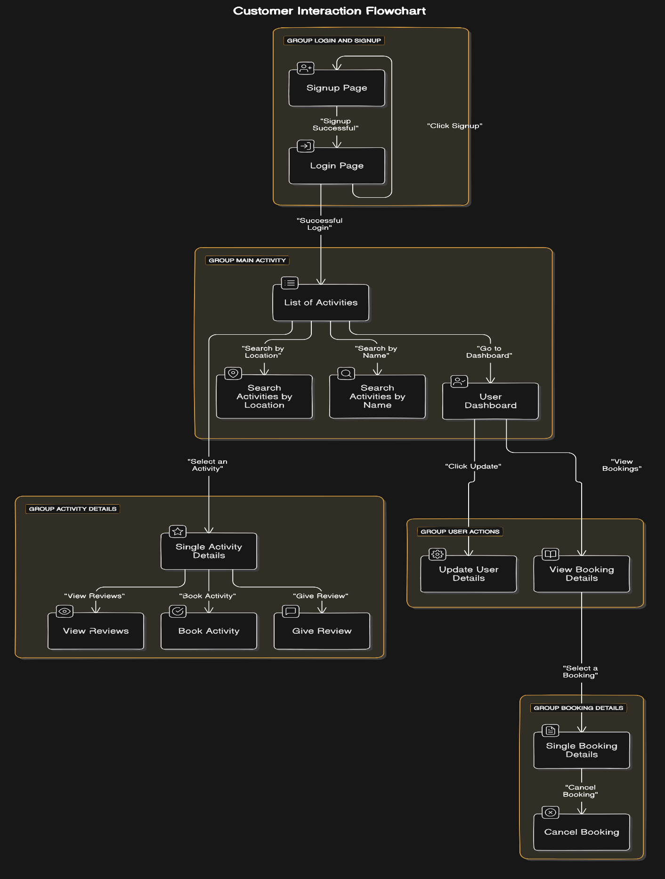

**Admin Interaction Diagram**

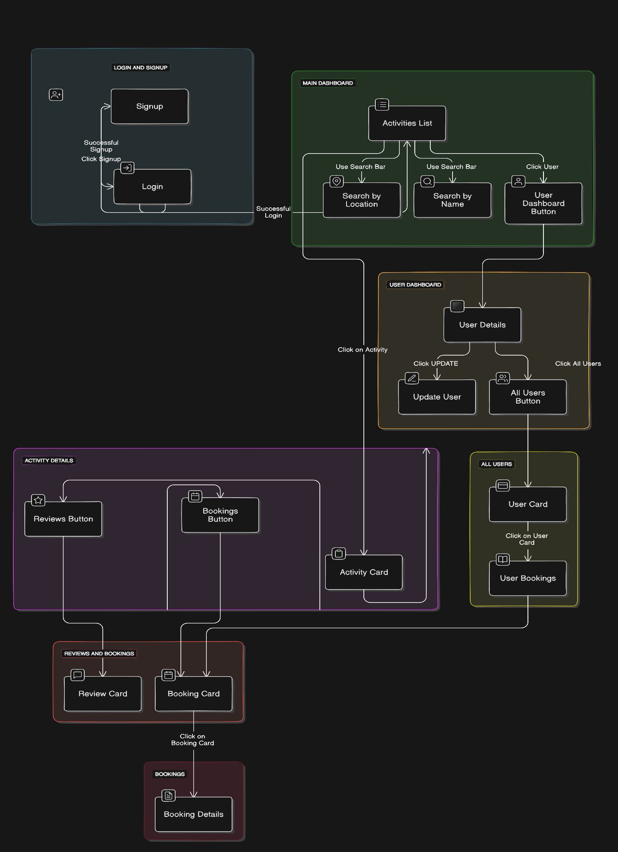

**Expert Interaction Diagram**

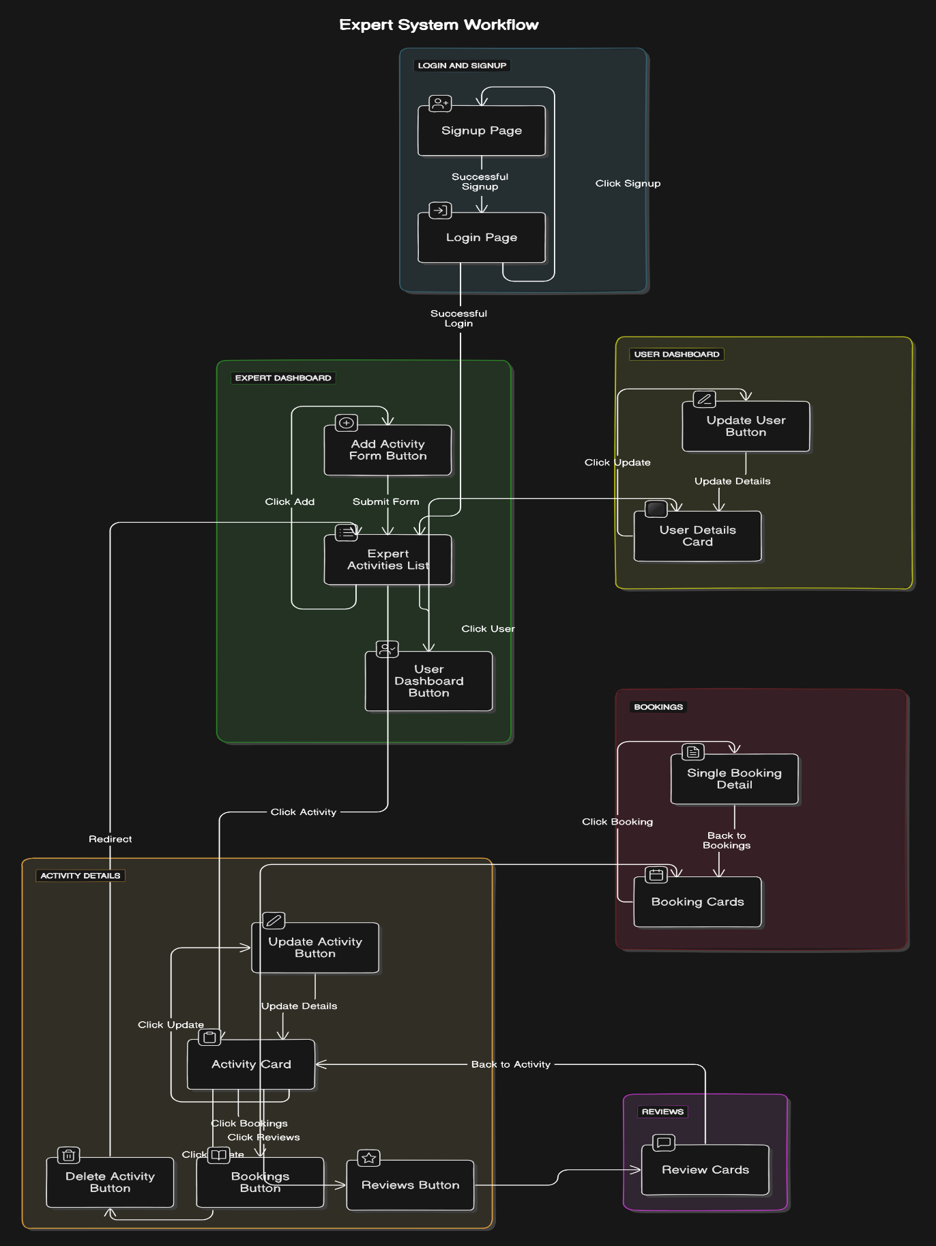

**Microservices**

**Authentication Microservice**

The Authentication Service is responsible for managing the login and signup functionalities within the application. Upon successful login, it generates a token containing essential user information, such as the email, userID, and role. This role-based token is pivotal in ensuring that users can only access functionalities pertinent to their permissions.

**Key Features:**

1.**Login and Signup**:

Provides secure login and signup processes for users.

Ensures data integrity and security during authentication.

2.**Token Generation**:

Generates a secure token upon login, embedding the user's email, userID, and role.

Tokens are used for subsequent authentication and authorization processes.

3.**Role-Based Access Control**:

Admin: Access to view all users.

Expert: Can add, delete, or update activities.

Customer: Can book activities.

Other roles with specific permissions can also be defined as needed.

4.**Security**:

Implements industry-standard security measures to protect user data.

Ensures that tokens are securely generated and validated.

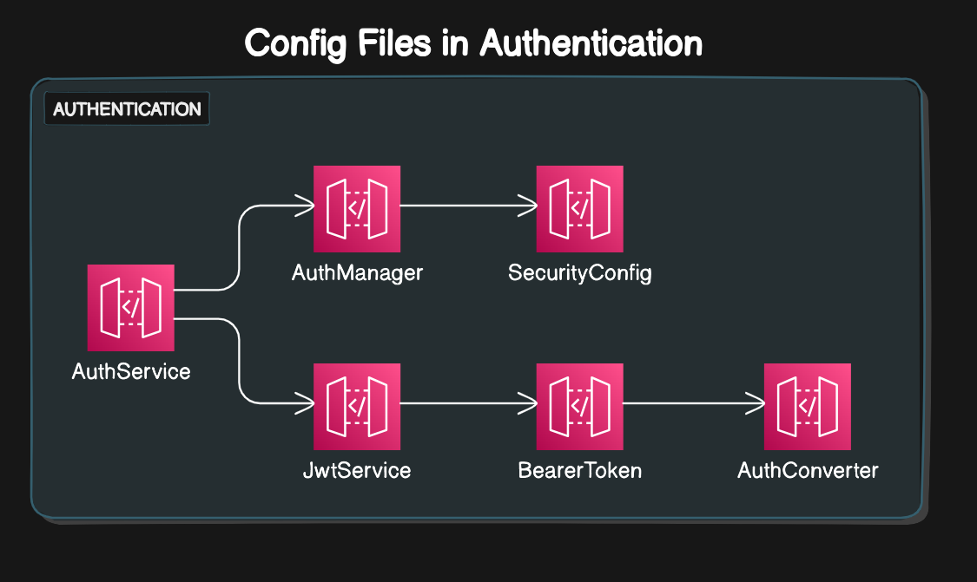

**User Microservice**

The User Microservice is a pivotal component of our application, facilitating user registration and management. It supports user registration as Customers, Experts, or Admins, ensuring a personalized and secure experience.

**Key Features:**

1.**Registration:** Users can register under three distinct roles - Customer, Expert, or Admin, tailoring their experience and access based on their role.

2.**Role-Based Access:** The system enforces strict role-based access control:

**Admins:** Can view and manage details of all users.

**Experts and Customers:** Can view and manage their details.

**3.User Management:**

**Profile Management:** Users can edit and delete their personal details, maintaining control over their information.

**Personal Data Retrieval:** Users have the ability to fetch their own details at any time, ensuring transparency and access to their data.

**Administrative Oversight:** Admins can fetch details of all users, providing comprehensive oversight and management capabilities.

**4.Data Storage:**

**MySQL Database:** All user details are stored in a MySQL database, ensuring reliable and scalable data management.

**Activity Service**

At the core of our application, the Activity Microservice orchestrates the management and interaction with activities, catering to the distinct roles of Experts, Admins, and Customers.

**Key Features:**

**1.Activity Management:**

**Expert Functions:** Empowers Experts to seamlessly add, update, and delete activities, ensuring dynamic content creation and curation.

**Admin Oversight:** Grants Admins visibility into all activities, facilitating comprehensive management and supervision.

**Customer Interaction:** Enables Customers to easily browse, book and review activities of interest, fostering engagement and participation.

**2.Homepage Display:**

**Customized Views:** Tailors the homepage to each user role:

**Customers and Admins:** Presents all activities as visually engaging cards, providing an intuitive browsing experience.

**Experts:** Displays activities listed by the respective Expert, streamlining their management workflow.

**3.Efficient Operations:** Optimizes operations for swift access to activities, search activities based on name and location, enhancing user satisfaction and system reliability.

**4.Database Storage:**

MongoDB Database: All experiences, including comments and ratings, are stored in a MongoDB database, ensuring reliable and scalable data management.

**Booking Microservice**

The Booking Microservice is a critical component of the Adventure Activity Booking application, providing robust functionality for managing activity bookings.

**Key Features:**

**1.Customer Bookings:**

**Booking an Activity:** Customers can easily book an activity by clicking the "Book" button on the activity page, streamlining the booking process.

**Canceling a Booking:** Customers can cancel their bookings by clicking the "Cancel" button next to the relevant booking in their personal bookings page, offering flexibility and control over their reservations.

**2.Expert Management:**

**View Bookings:** Experts have the capability to view all bookings associated with the activities they have listed, providing them with insight and oversight into participation and engagement.

**3.Admin Oversight:**

**Comprehensive Booking Access:** Admins can view all bookings across the platform, ensuring comprehensive management and oversight.

**Activity-Specific Bookings:** Admins can filter and view bookings for specific activities, allowing targeted management and analysis.

**Customer-Specific Bookings:** Admins can also access bookings made by individual customers, facilitating personalized support and administration.

**5.Data Storage:**

MySQL Database: All bookings are stored in a MySQL database, ensuring reliable and scalable data management.

**Experience Microservice**

The Experience Microservice is an integral part of our Adventure Activity Booking application, enabling users to share and manage their experiences seamlessly.

**Key Features:**

**1.Customer Interactions:**

Write Comments and Ratings: Customers can write detailed comments and provide a rating from 1 to 5 for each activity they participate in, sharing valuable feedback and insights.

Update Experiences: Customers have the flexibility to update their comments and ratings, ensuring their feedback remains accurate and relevant.

**2.Expert Oversight:**

View Experiences: Experts can access all comments and ratings related to the activities they have listed, allowing them to gain insights into customer satisfaction and areas for improvement.

**3.Admin Management:**

Comprehensive Access: Admins can view all experiences across all activities, providing them with a holistic view of customer feedback and engagement.

Manage Feedback: Admins can oversee the overall experience feedback to ensure quality and address any issues or concerns promptly.

**4.Data Storage:**

MySQL Database: All experiences, including comments and ratings, are stored in a MySQL database, ensuring reliable and scalable data management.

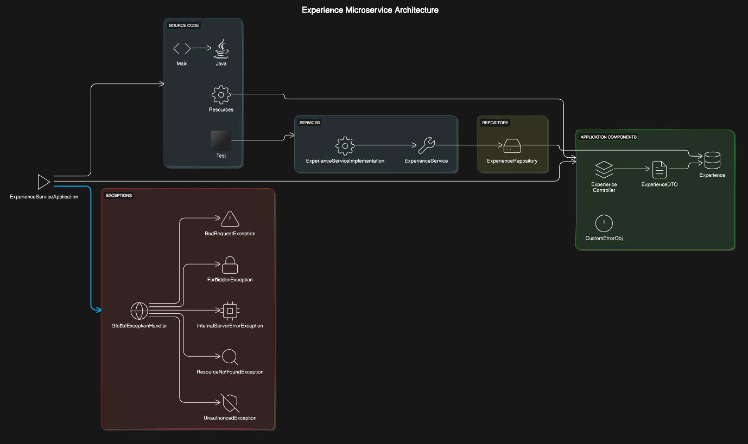

**Database Diagram**

**Conclusion**

As my final project during my training at Capgemini, focusing on Java Full Stack and Angular development, this comprehensive adventure booking platform represents a culmination of the skills and knowledge I've acquired. The platform leverages modern technology to offer a streamlined process for discovering, booking, and sharing adventurous experiences, making it an invaluable resource for thrill-seekers around the globe.

By integrating a vast global activity database, a user-friendly interface, a seamless booking process, and robust feedback features, I've created a solution that addresses the needs of adventure enthusiasts. This project has provided me with hands-on experience in full-stack development, emphasizing the importance of both front-end and back-end technologies in creating a cohesive and user-centric application.

Working on this project has not only honed my technical skills in Angular and Java but also reinforced the importance of user experience and efficient system design. I'm proud of the work I've accomplished and excited about the potential impact this platform can have on the adventure tourism industry. This project marks a significant milestone in my career as a developer and sets a solid foundation for future endeavors in full-stack development.